**MA4605 Lecture 8B**

The Shewart control charts (from last class) and CUSUM charts (coming soon) are commonly used quality control methods to detect deviations from bench mark values.

These are used after a process has already been put in place and functioning under control to a specified set of criteria. Continuing sampling and charting the results can then provide early detection should the process becomes faulty (out of control).

In industrial production, the out of control situation is usually due to machine wear and tear, accidental damage, or malfunctioning somewhere in the assembly line. In clinical practice, the out of control situation may occur when practices changes, or when the underlying epidemiological pattern changes.

The Shewart control chart was developed first to quality control normally distributed measurements.

The chart consists of continuing checking of values, and triggers the out of control alarm if 2 consecutive measurements exceeded 3 standard errors from the mean, or 3 consecutive measurements exceeding 2 standard errors from the mean, or because one of the other 8 tests.

The Shewart chart is therefore effective to detect sudden and large departures from the bench mark.

In the last class we looked at Control Charts for the process mean (i.e. X.bar charts).

In this class we will look at some brief worked examples, and introduce some more control charts.

* Control Charts for the Process Range
* Control Charts for the Process Standard Deviation
* Control Charts for the Process Proportion

(We will not use the R package qcc in this particular class, although it is relevant to this material)

**Worked Examples**

The table below presents the weights, in ounces, for a sequence of 15 rational subgroup samples of potato chips, with n = 4 for each sample., The sample means, standard deviations, and ranges also are reported.

|  |  |  |  |  |  |  |  |
| --- | --- | --- | --- | --- | --- | --- | --- |
|  | item 1 | item 2 | item 3 | item 4 | mean | std.dev | range |
| 1 | 15.01 | 15.16 | 14.98 | 14.8 | 14.99 | 0.148 | 0.36 |
| 2 | 15.09 | 15.08 | 15.14 | 15.03 | 15.08 | 0.045 | 0.11 |
| 3 | 15.04 | 14.93 | 15.1 | 15.13 | 15.05 | 0.088 | 0.2 |
| 4 | 14.9 | 14.94 | 15.03 | 14.92 | 14.95 | 0.057 | 0.13 |
| 5 | 15.04 | 15.08 | 15.05 | 14.98 | 15.04 | 0.042 | 0.1 |
| 6 | 14.96 | 14.96 | 14.81 | 14.91 | 14.91 | 0.071 | 0.15 |
| 7 | 15.01 | 14.9 | 15.1 | 15.03 | 15.01 | 0.083 | 0.2 |
| 8 | 14.71 | 14.77 | 14.92 | 14.95 | 14.84 | 0.116 | 0.24 |
| 9 | 14.81 | 14.64 | 14.8 | 14.95 | 14.8 | 0.127 | 0.31 |
| 10 | 15.03 | 14.99 | 14.89 | 15.03 | 14.98 | 0.066 | 0.14 |
| 11 | 15.16 | 14.95 | 14.91 | 14.83 | 14.96 | 0.141 | 0.33 |
| 12 | 14.92 | 15.01 | 15.05 | 15.02 | 15 | 0.056 | 0.13 |
| 13 | 15.06 | 14.95 | 15.03 | 15.02 | 15.02 | 0.047 | 0.11 |
| 14 | 14.99 | 15.04 | 15.14 | 15.11 | 15.07 | 0.068 | 0.15 |
| 15 | 14.94 | 14.9 | 15.08 | 15.17 | 15.02 | 0.125 | 0.27 |

Overall Mean, and Means of standard deviations and ranges

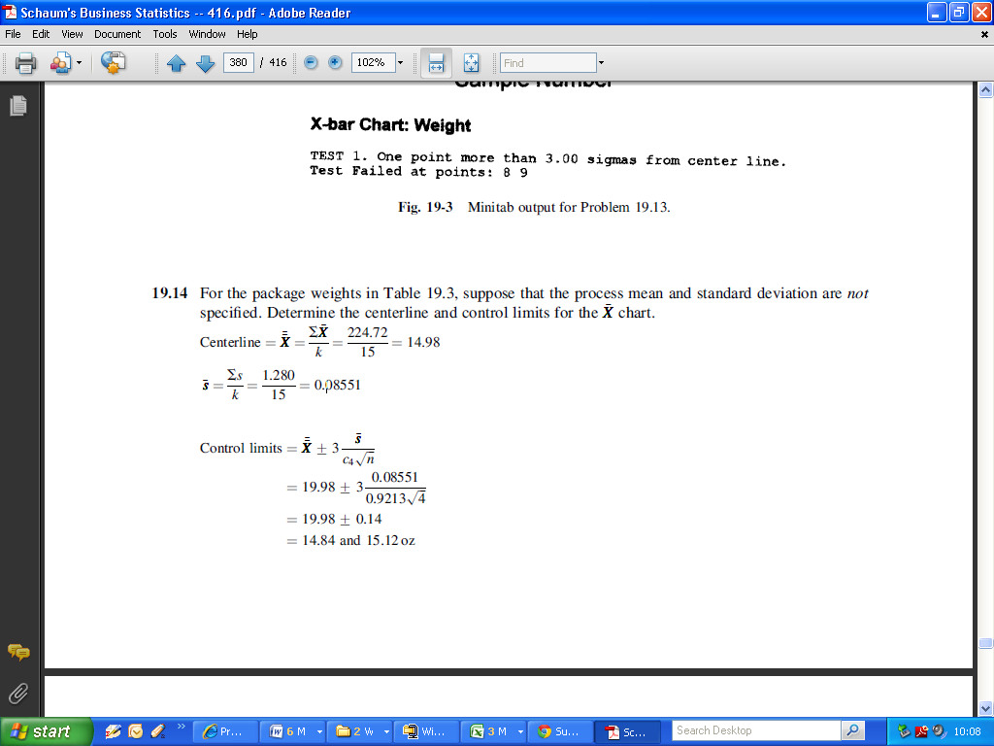



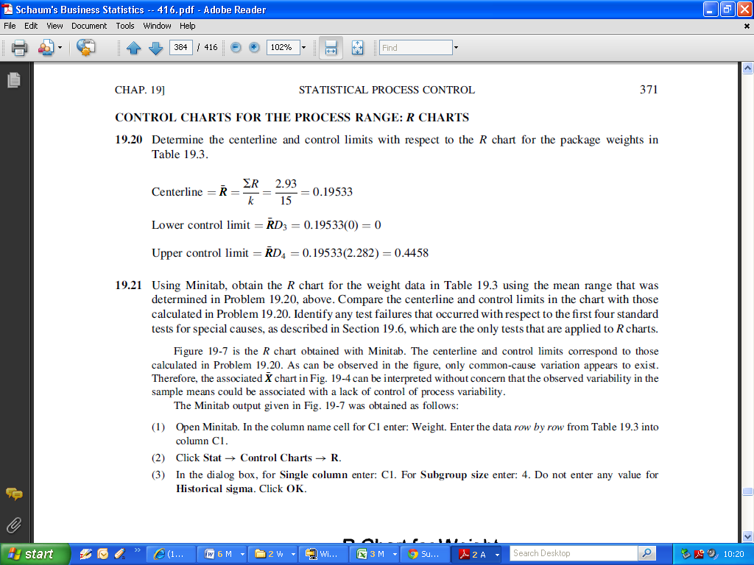

Recall the formula from last week:

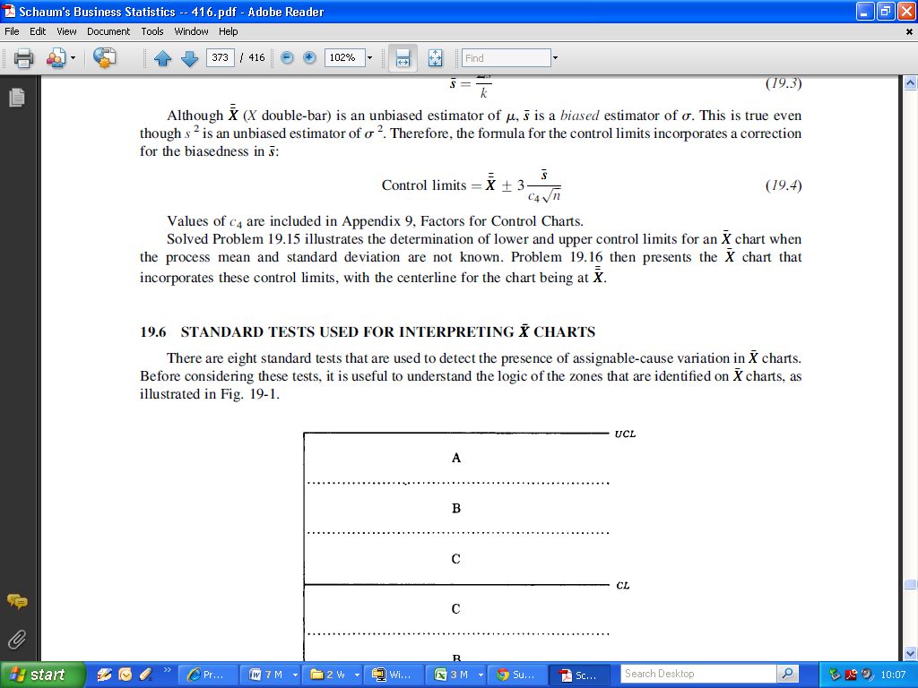

The value for ***c4*** is computed using a special table, and is dependent on the sample size. For a batch sample size of 4, the value for ***c4*** is 0.9213.



 

Control Limits 14.98 ± 0.14 = (14.84,15.12)

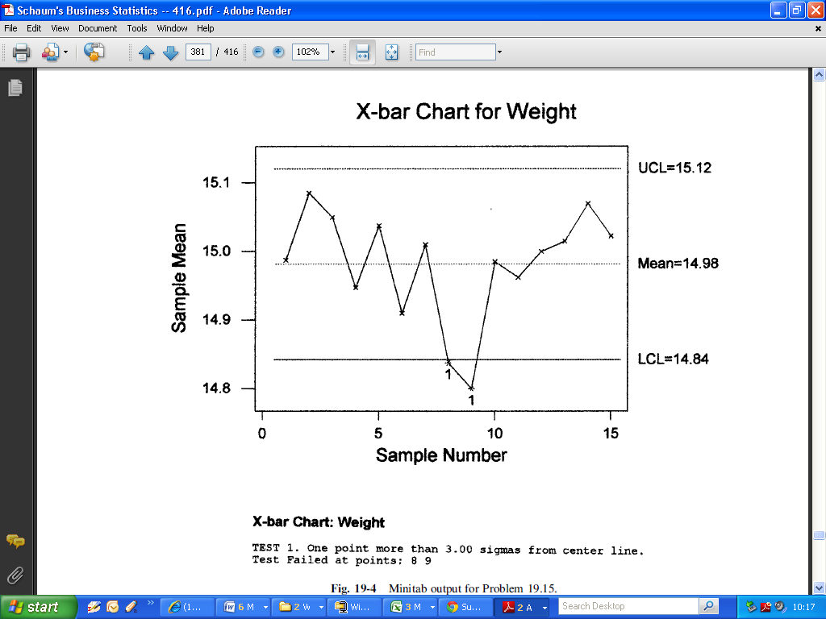

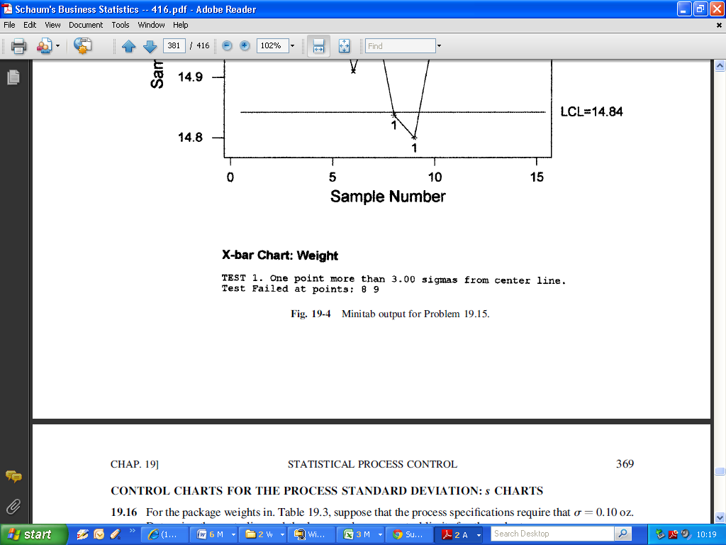

**CONTROL CHARTS FOR THE PROCESS RANGE: R CHARTS**

The ***R*** chart is an alternative to the ***s*** chart for assessing the stability of a process with respect to variability. The s chart is preferred because this measure of variation considers the value of every sampled item, and thus leads to a more precise measure of variability.

**R** charts were predominant for many years because of ease of

computation, but this advantage is no longer relevant given the use of programmable devices in process control.

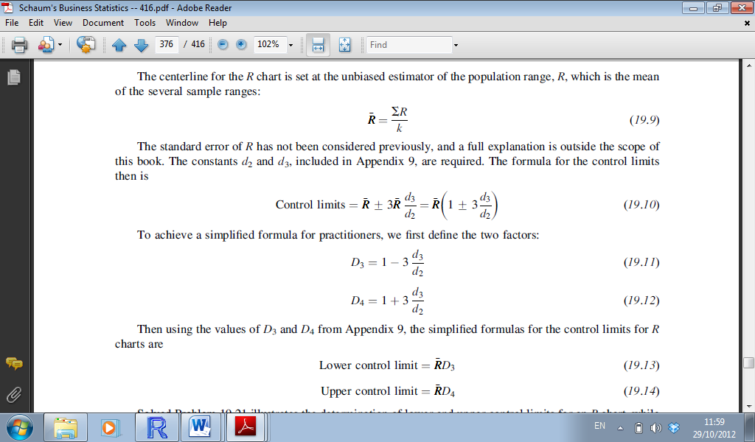

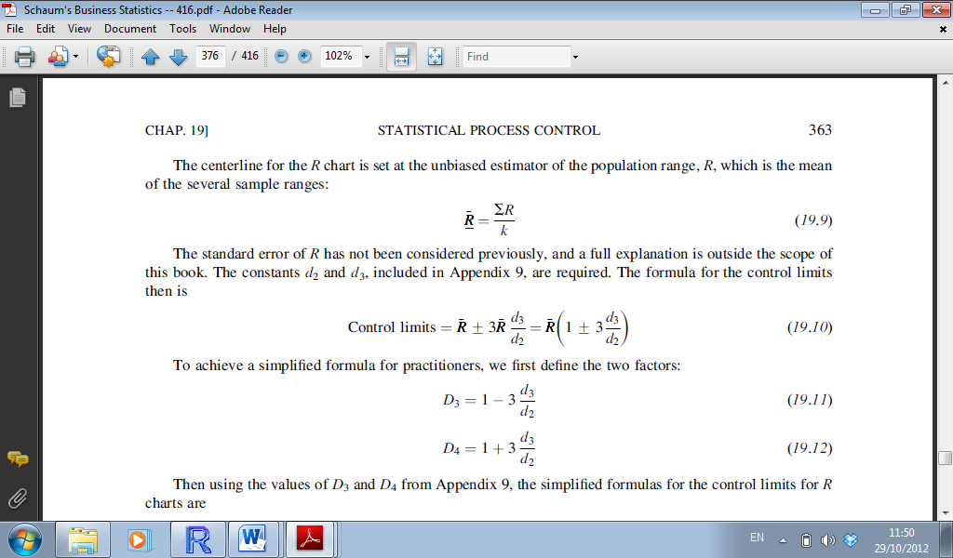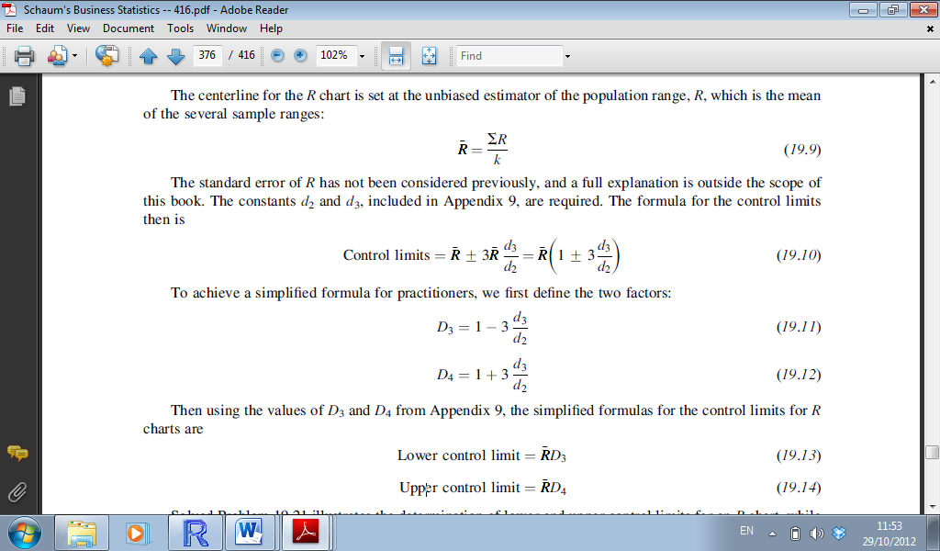

If the **R** chart indicates that the process is unstable in terms of process variability, then this issue should be addressed before there is any attempt to assess process stability with respect to the process mean.

**Example:**

Determine the centre-line and control limits with respect to the **R** chart for the package weights.

The values for ***D3*** and ***D4*** are determinable from the tables.

As the sample size is 4, the values are 0 and 2.282 respectively.



As can be observed in the figure, only common-cause variation appears to exist. Therefore, the associated ***X.bar*** chart can be interpreted without concern that the observed variability in the sample means could be associated with a lack of control of process variability.

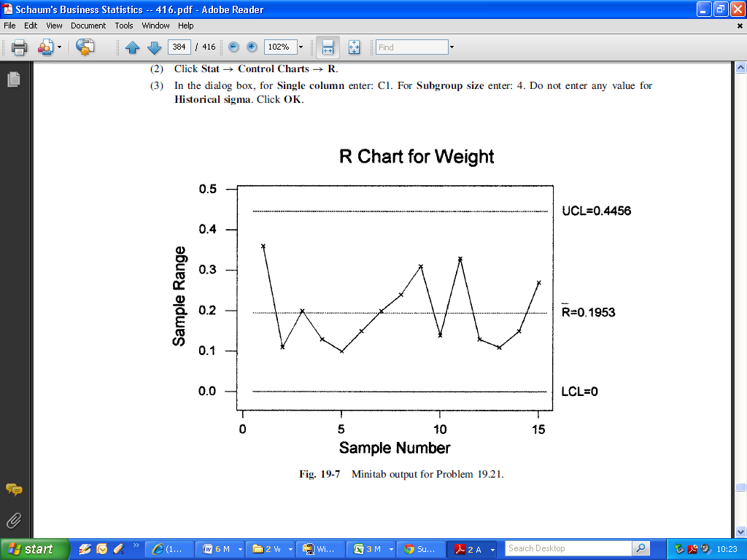

CONTROL CHARTS FOR THE PROCESS STANDARD DEVIATION: s CHARTS

*Process Standard Deviation Known*. The centre-line for the control chart is not set at the designated process standard deviation, as one might expect. The reason is that even though s2 is an unbiased estimator of

σ2, the sample standard deviation s is a biased estimator of σ.

Because it is required that the centreline be applicable for sample standard deviations, the value of the process σ must be adjusted so that the expected biasedness in the sample standard deviations is included:

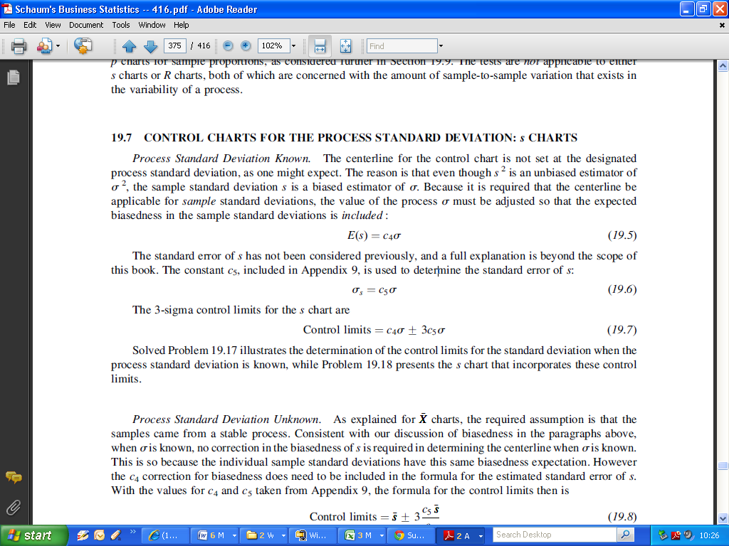

The constant ***c5***, included in the Tables, is used to determine the standard error of s:

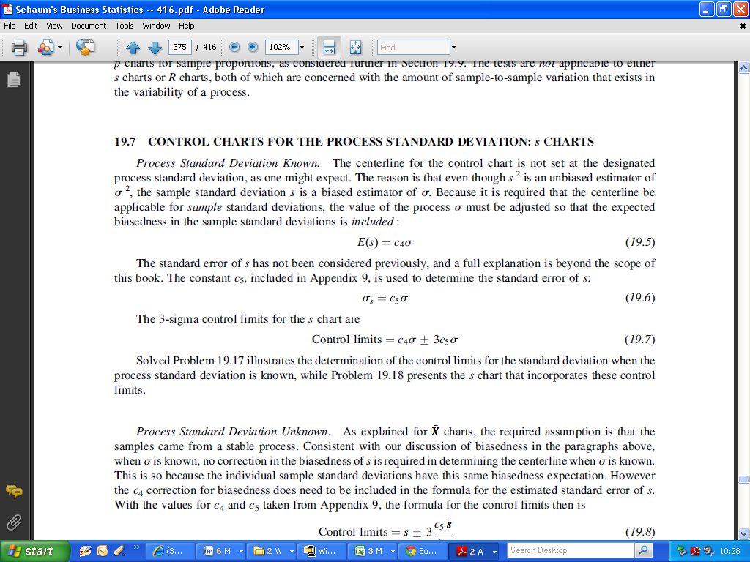

The 3-sigma control limits for the ***s*** chart are

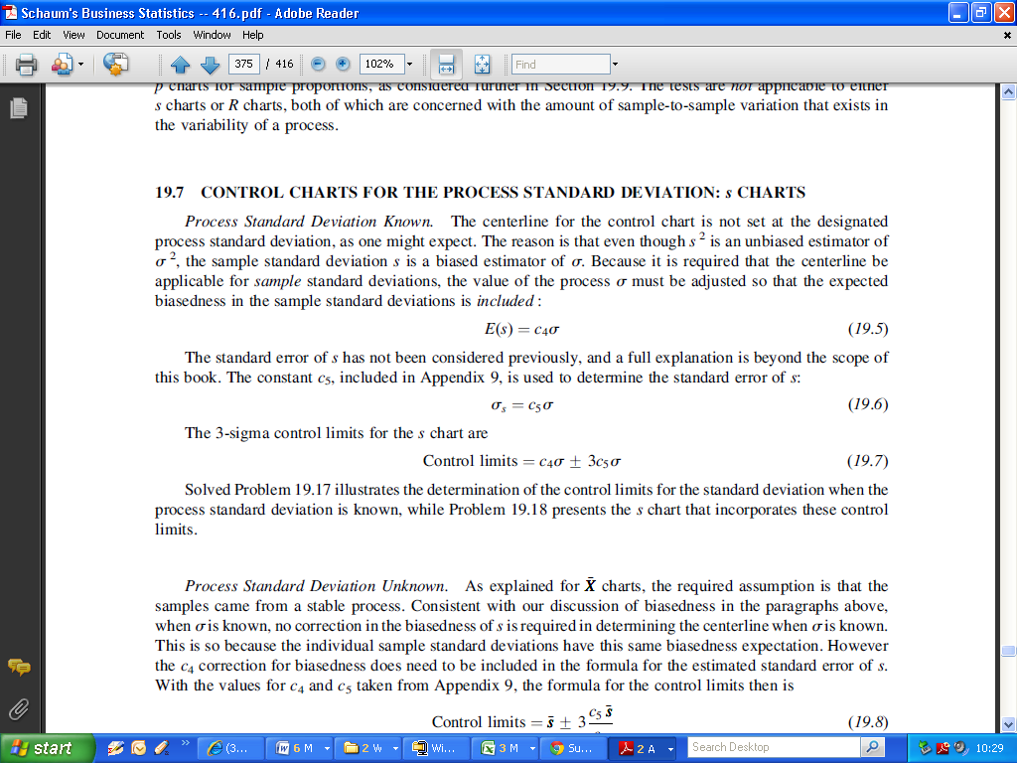

*Process Standard Deviation Unknown.*

As explained for ***X.bar*** charts, the required assumption is that the samples came from a stable process. Consistent with emphasis on biasedness when σ is known, no correction in the biasedness of s is required in determining the centre-line when s is known.

This is so because the individual sample standard deviations have this same biasedness expectation. However the ***c4*** correction for biasedness does need to be included in the formula for the estimated standard error of s.

With the values for ***c4*** and ***c5*** taken from Tables, the formula for the control limits then is

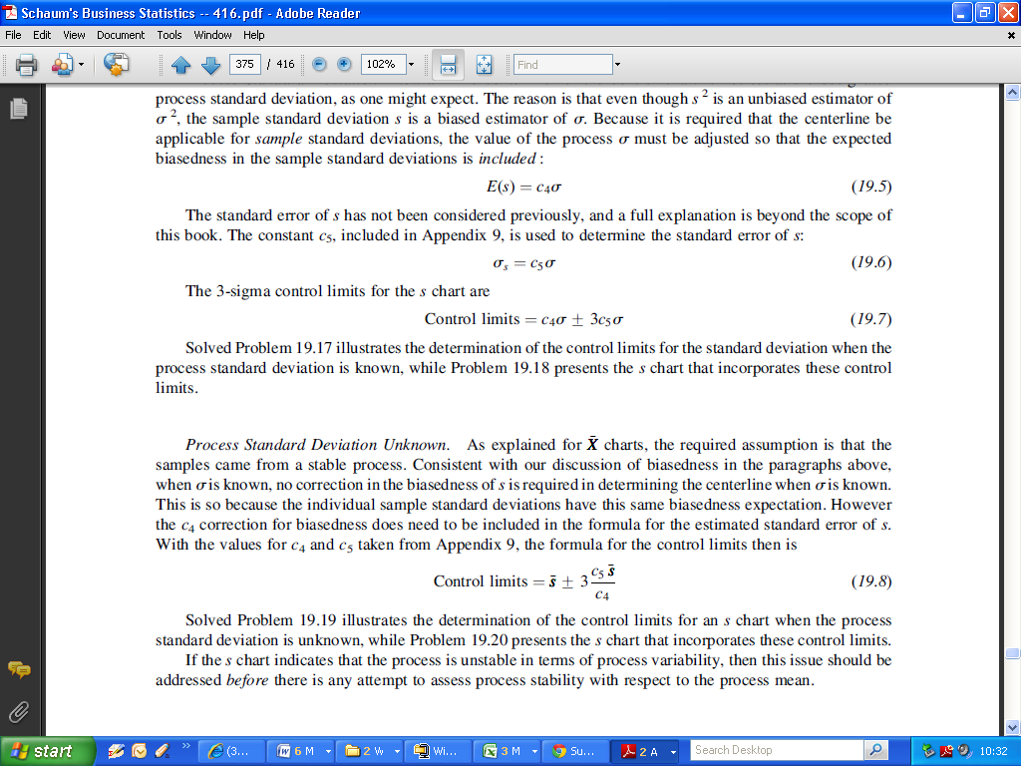

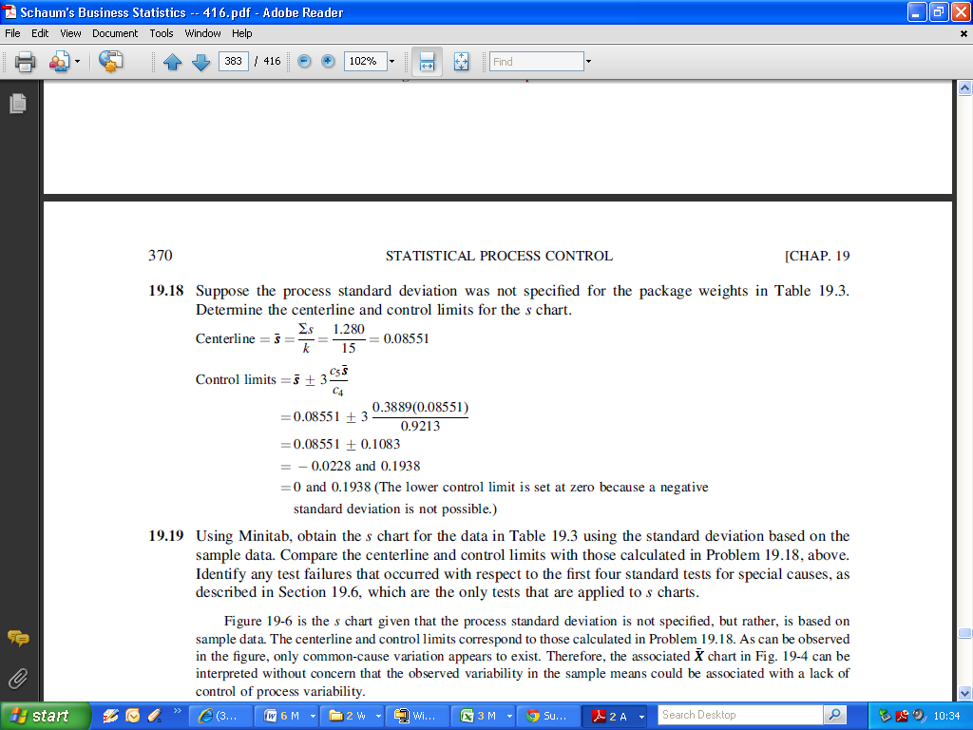

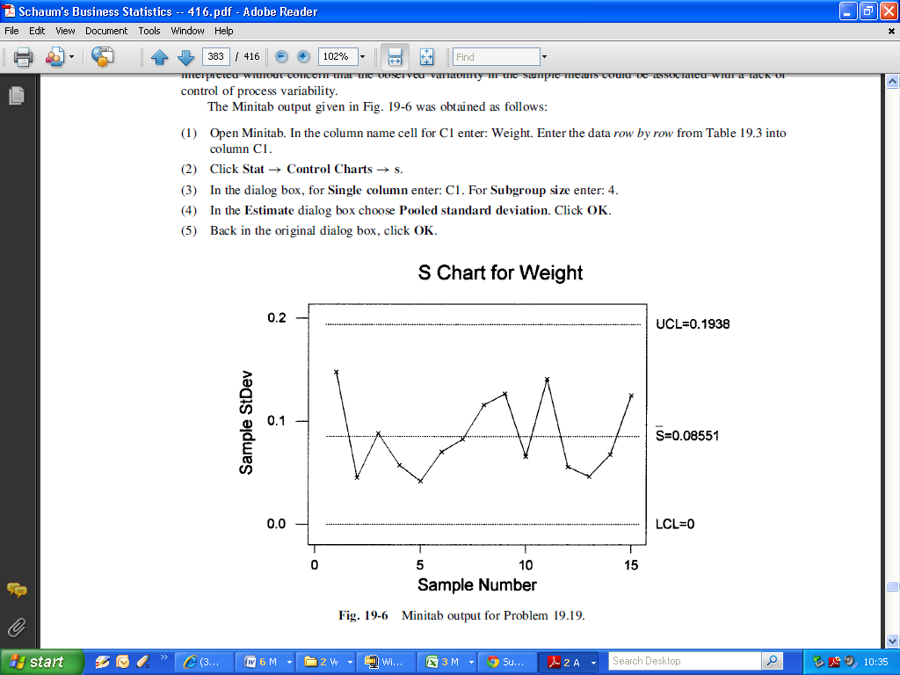

***CONTROL CHARTS FOR THE PROCESS PROPORTION: p CHARTS***

Process Proportion Known.

The process proportion would be known either because it is a process specification, such as the proportion defective that are acceptable, or it is based on historical observations of the process when it was deemed to be stable. The centre-line for the p chart is set at the process proportion, p. Using the 3-sigma rule, the control limits are set by the same method used to determine critical values for hypothesis testing.

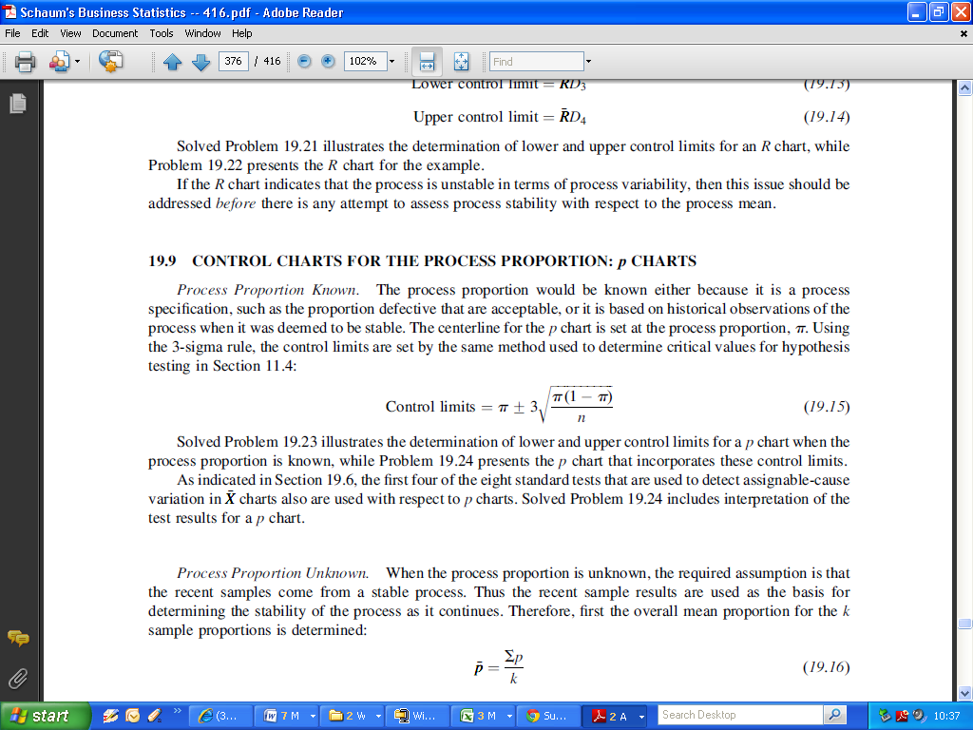

Process Proportion Unknown.

When the process proportion is unknown, the required assumption is that the recent samples come from a stable process. Thus the recent sample results are used as the basis for determining the stability of the process as it continues. Therefore, first the overall mean proportion for the k sample proportions is determined:

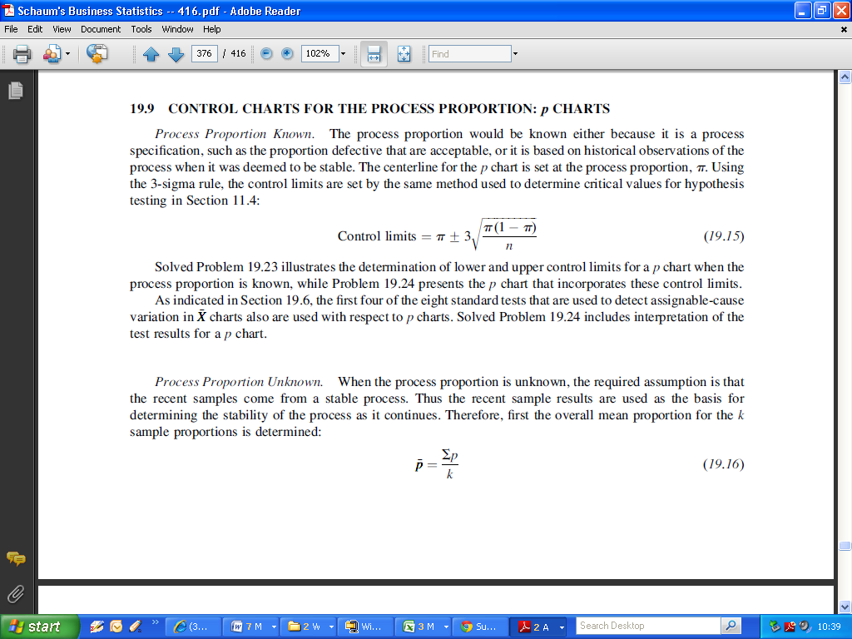

An alternative formula for p.bar is to sum the number of items in each sample that have the identified characteristic, such as the number of defectives in each sample, and then divide by the total number of items in all k samples. Assuming equal sample sizes, the formula is

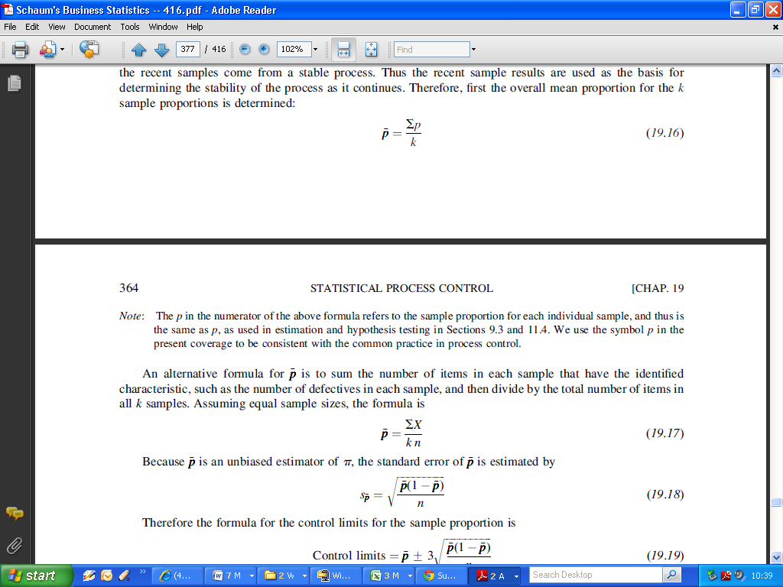

Because ***p.bar*** is an unbiased estimator of the population proportion π, the standard error of ***p.bar*** is estimated by

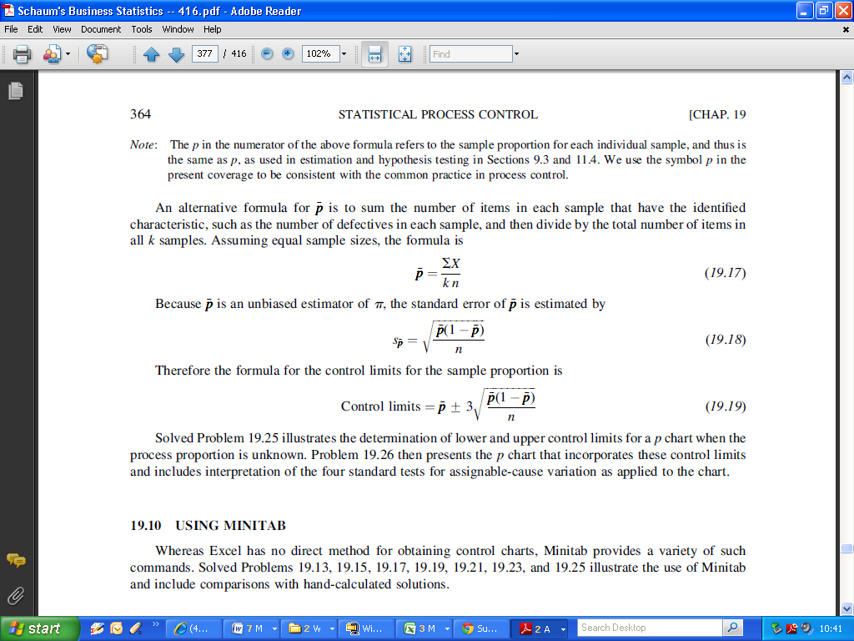

Therefore the formula for the control limits for the sample proportion is

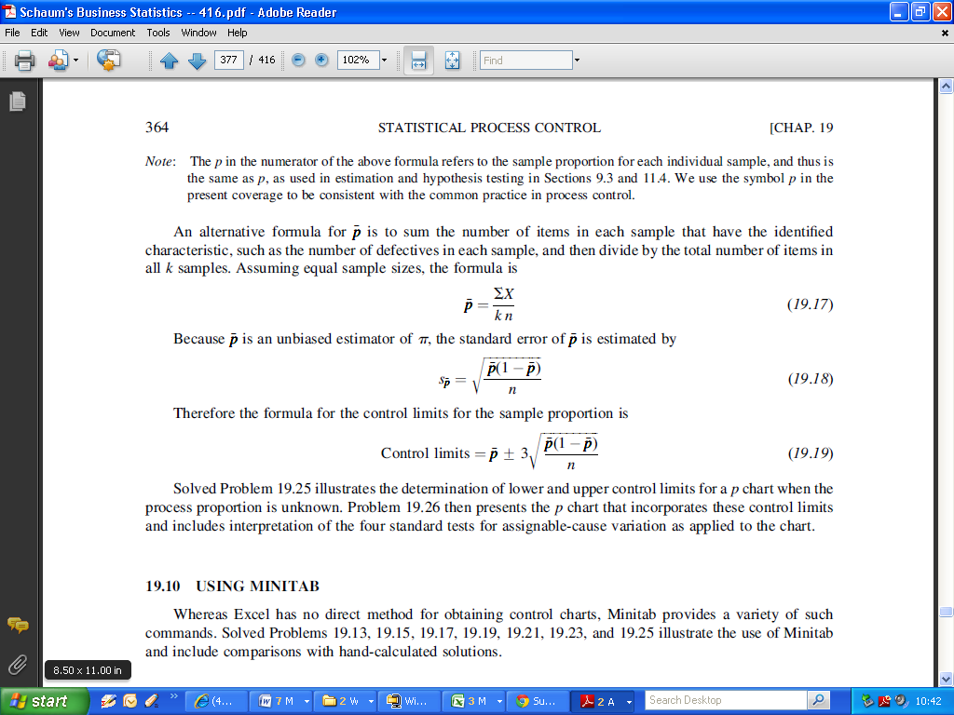

***Example:***

When a coupon redemption process is in control, then a maximum of 3 percent of the rebates are done incorrectly, for a maximum acceptable proportion of errors of 0.03.

For 20 sequential samples of 100 coupon redemptions each, an audit reveals that the number of errors found in the subgroup samples is: 2, 2, 3, 6, 1, 3, 6, 4, 7, 2, 5, 0, 3, 2, 4, 5, 3, 8, 1, and 4.

Determine the control limits for the proportion of errors per sample, given that the process proportion is specified as being π =0.03.

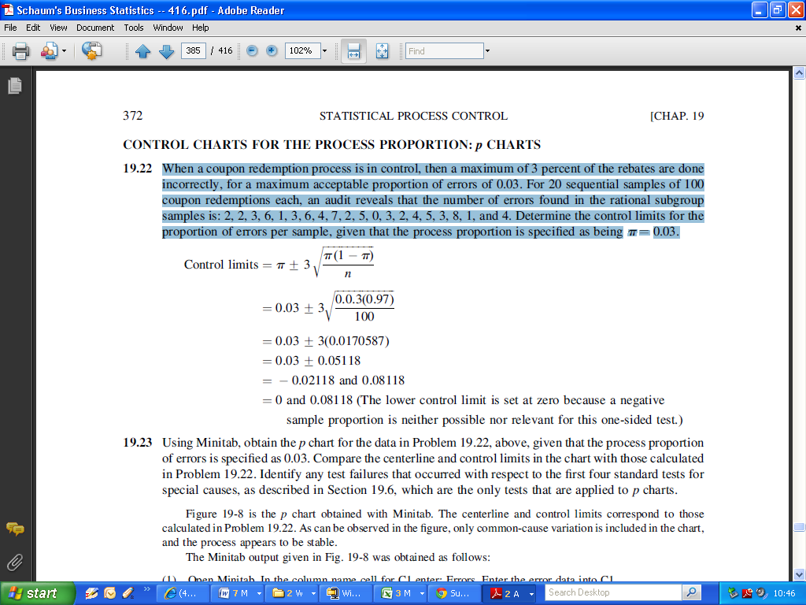

Control Limits are 0 and 0.08118

(The lower control limit is set at zero because a negative sample proportion is neither possible nor relevant)

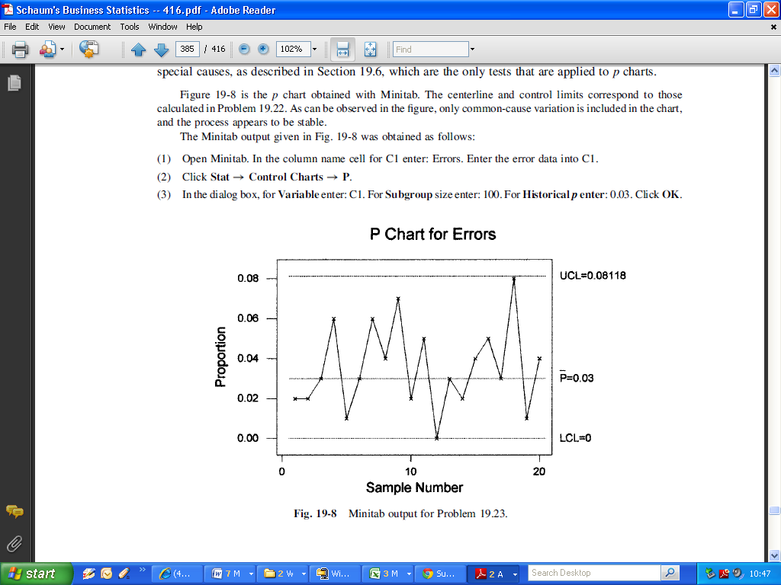

(P charts are implementable in the ***R*** statistical Programming environment using the *qcc* package. We will revert to this next class)